A Comprehensive Analysis of Financial Performance: Insights from a Leading Banks

1.INTRODUCTION:

* 1. OVERVIEW:

The banking industry world-wide is being transformed. The global forces for change include technological innovation; the deregulation of financial services at the national level and opening-up to international competition; and - equally important - changes in corporate behavior, such as growing disintermediation and increased emphasis on shareholder value. In addition, recent banking crises in Asia and Latin America have accentuated these pressures.

* 1. PURPOSE:

To Extract the Insights from the data and put the data in the form of visualizations, Dashboards and Story we employed Tableau tool.

2. PROBLEM DEFINITION AND DESIGN THINKING:

2.1: EMPATHY MAP

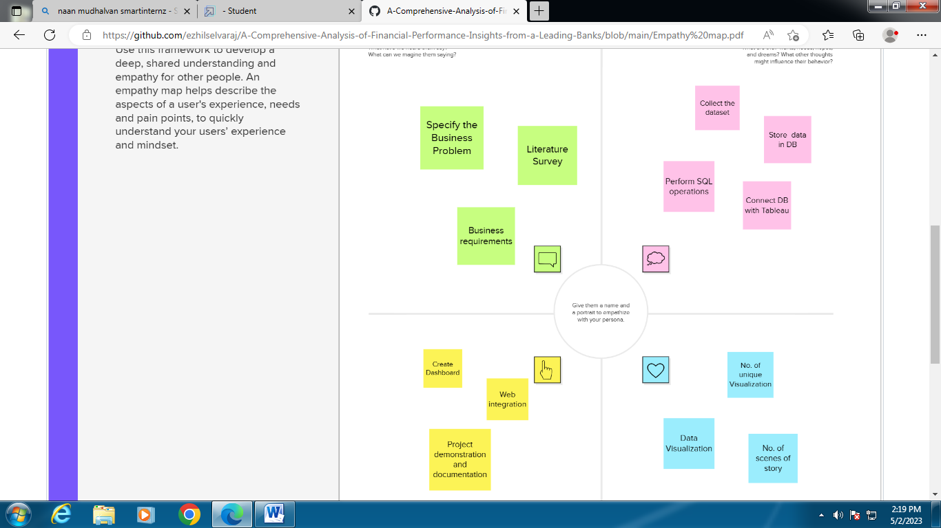

2.2 BRAINSTROMING IDEAS:

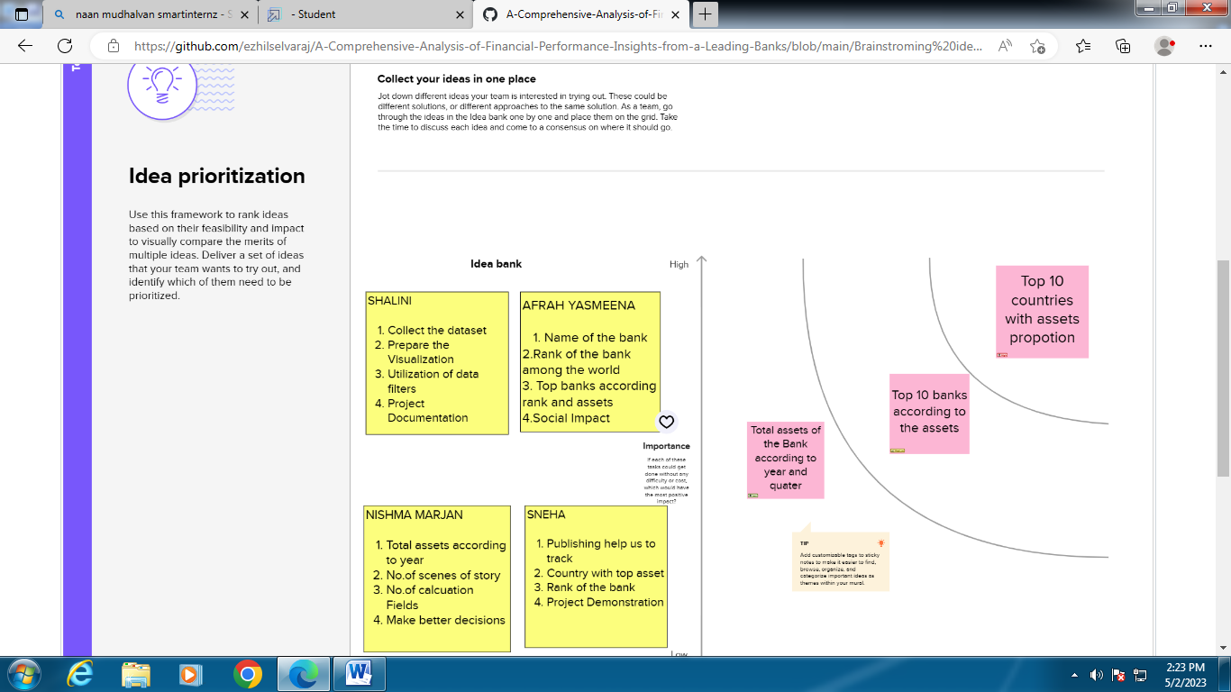

**3. RESULT:**

3.1: Top banks according rank and assets:

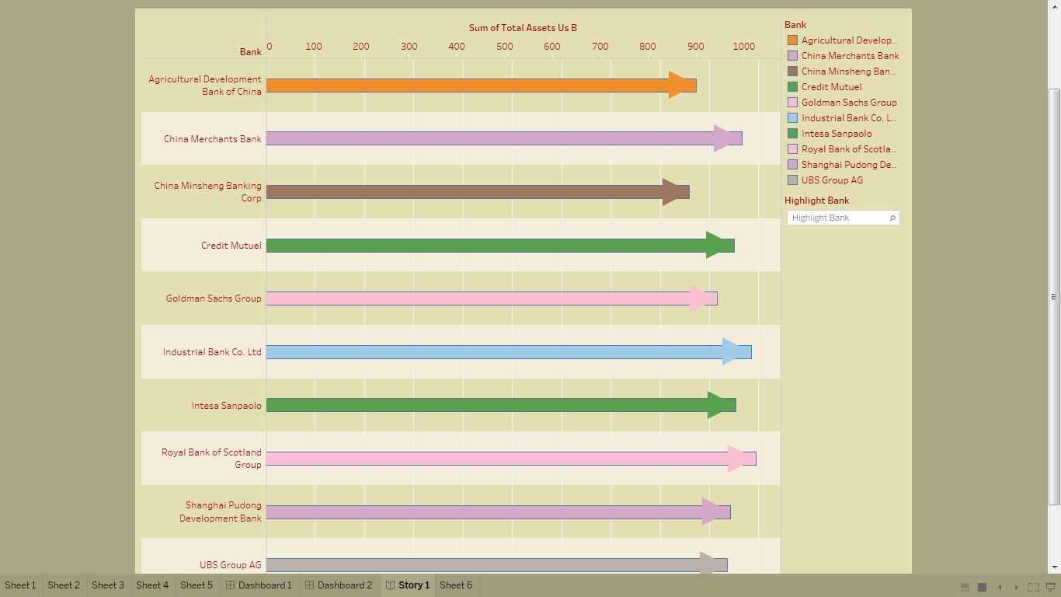

3.2: Top banks according to country based on total assets:

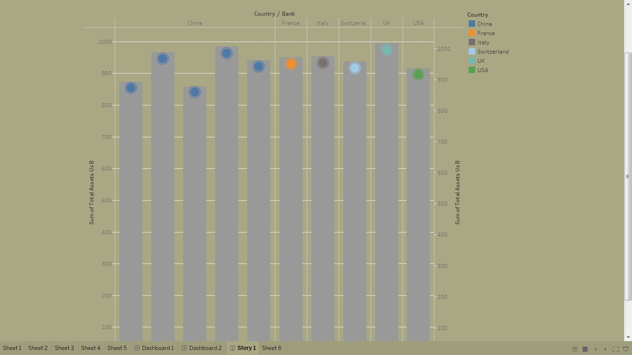

3.3: Top 10 countries with assets proportion:

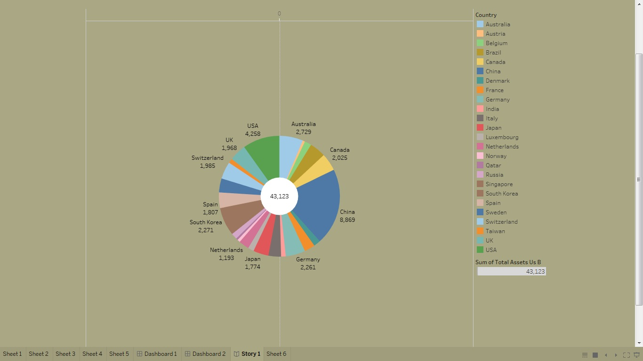

3.4: Country with total assets using funnel chart in increasing order:

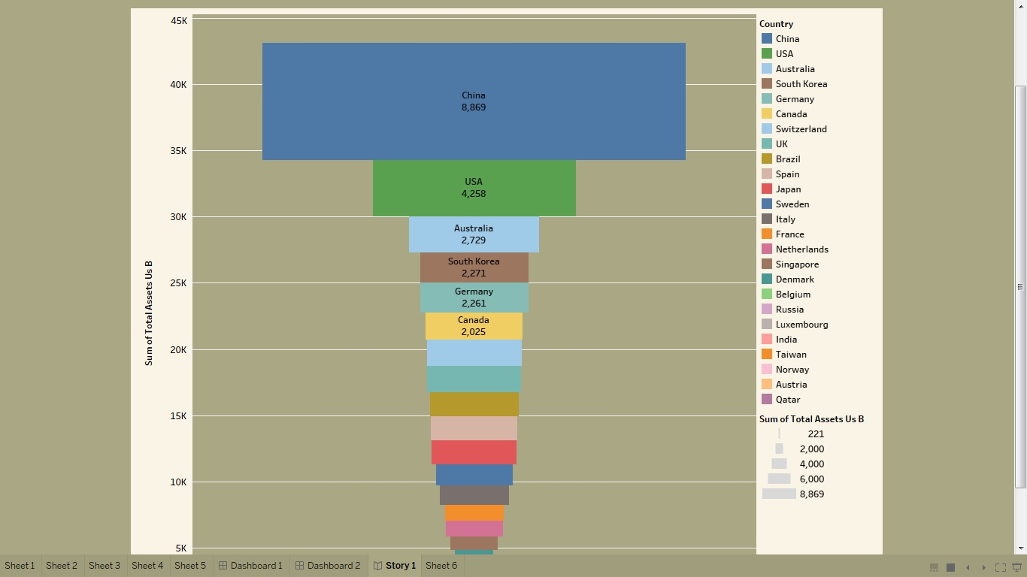

3.5 Total assets analysis according to year and quarter:

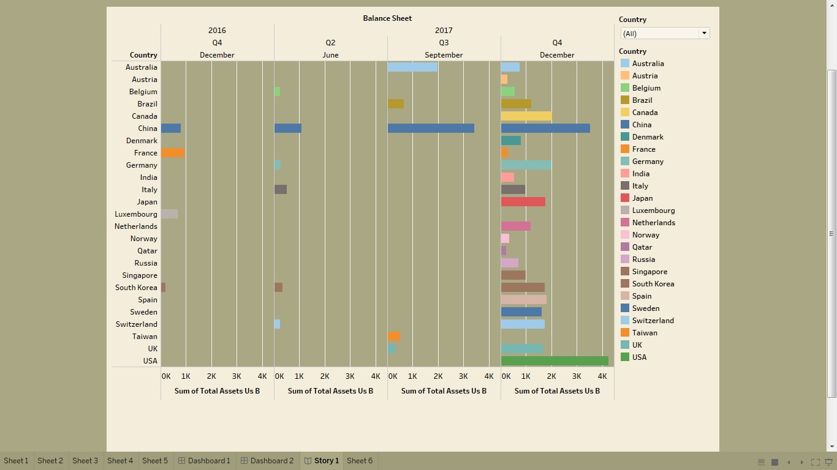

**DASHBOARD:**

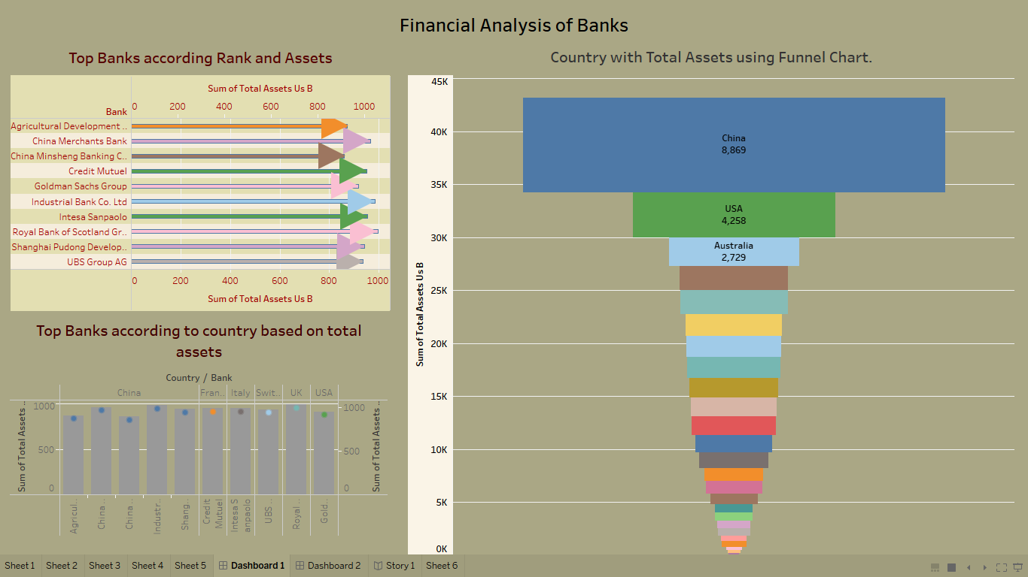

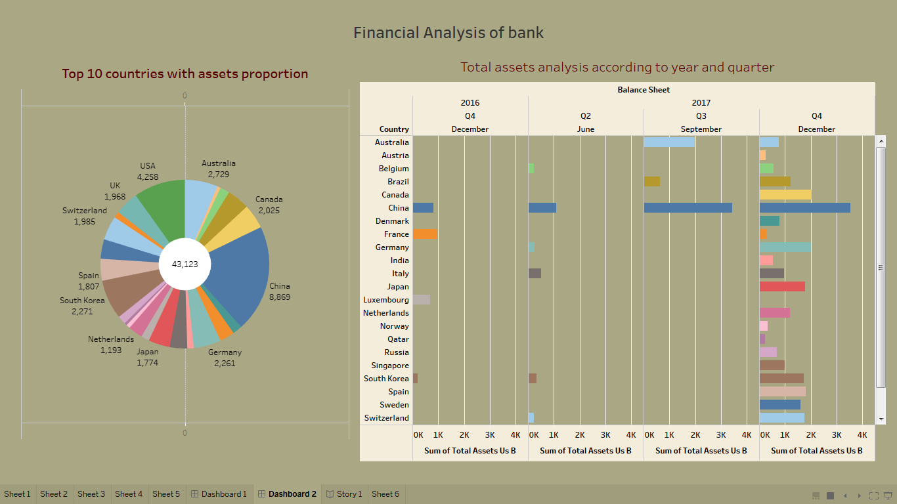

**STORY:**

In story, we create the presentation of different visualization.

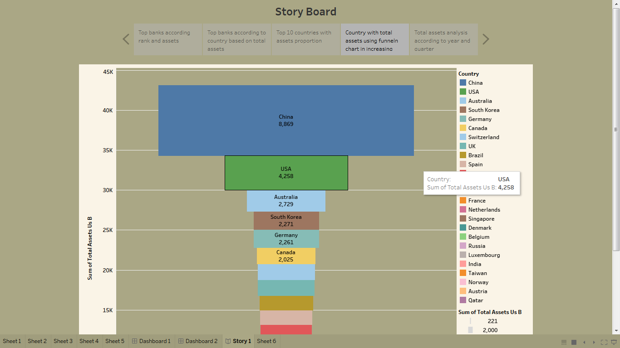

**4. ADVANTAGES AND DISADVANTAGES:**

Advantages:

* High performance
* Mobile friendly
* Extensive customer resources
* External Mobile support

Disadvantages:

* poor versioning
* Need manual report
* No automatic refreshing of report.

**5. APPLICATIONS:**

* **Data Visualization:** Tableau is known for its ability to create stunning and interactive visualizations. With Tableau, users can easily create charts, graphs, maps, and other visual representations of their data, making it easier to understand and communicate complex data.
* **Data Exploration:** Tableau allows users to explore their data in real-time and quickly identify trends, patterns, and outliers. Users can interact with their data in various ways, such as filtering, drilling down, and pivoting, to uncover insights and make informed decisions.
* **Predictive Analytics:** Tableau can be used to perform predictive analytics, allowing users to make forecasts and identify trends in their data. With Tableau's predictive modeling capabilities, businesses can make data-driven decisions based on insights and projections.
* **Data Collaboration:** Tableau is designed to facilitate collaboration and sharing of data insights within an organization. With Tableau, users can share their visualizations and dashboards with others, allowing them to collaborate and make decisions based on real-time data.

**6. CONCLUSION:**

By using tableau, our team analysis the financial assets and ranks of bank. We create dashboard and story. Also, we upload the all files in ‘getrepo’ . we, create project documentation and demonstration.